**Input**

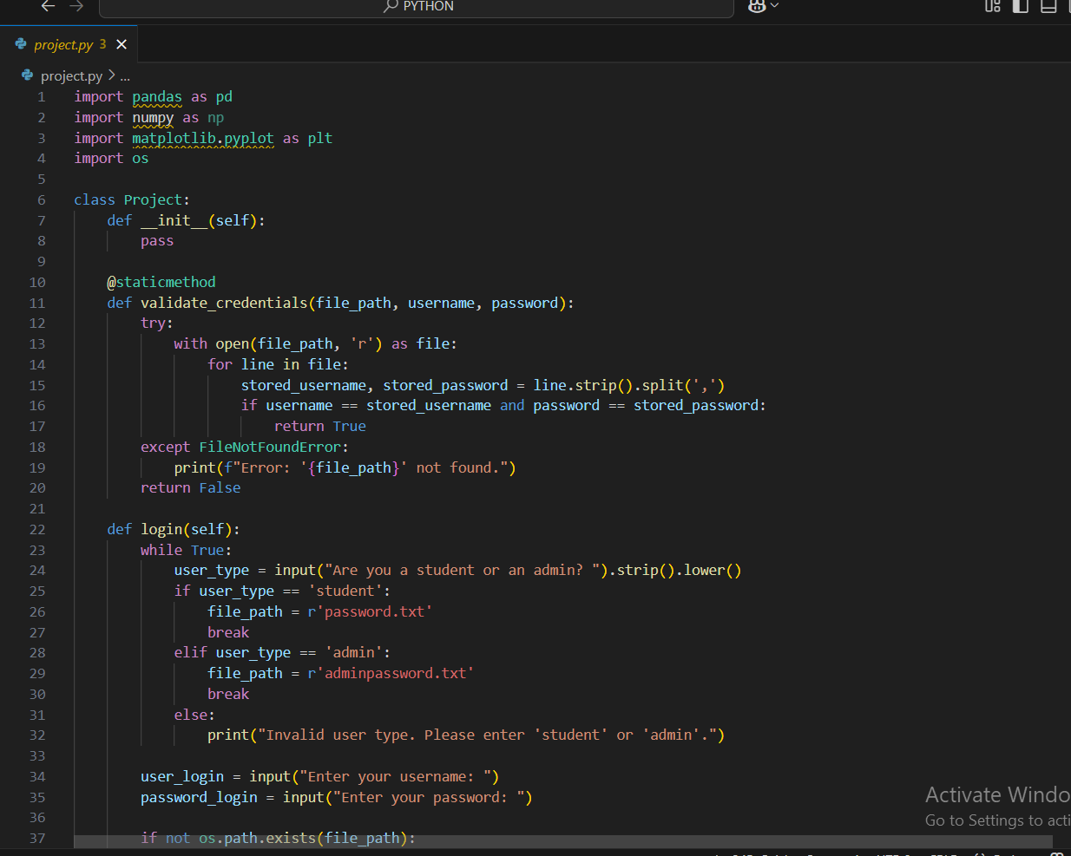

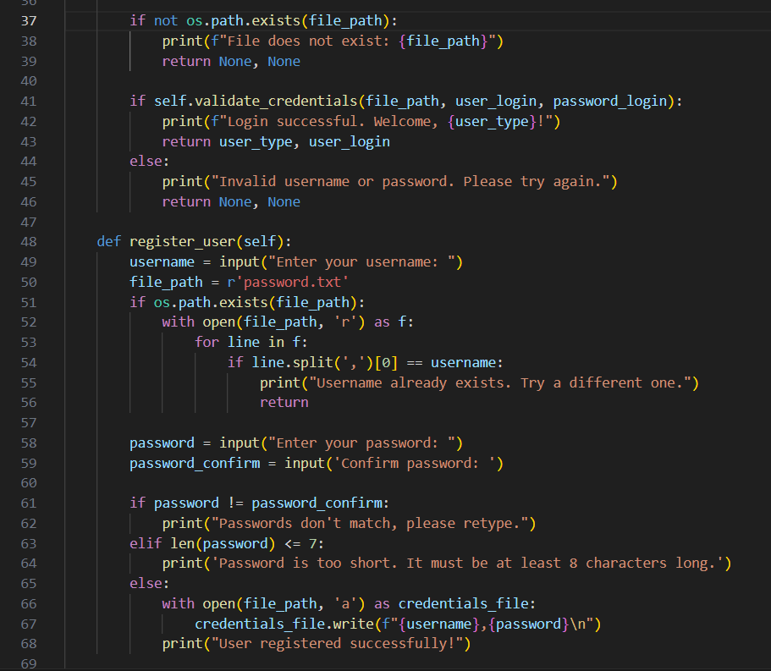

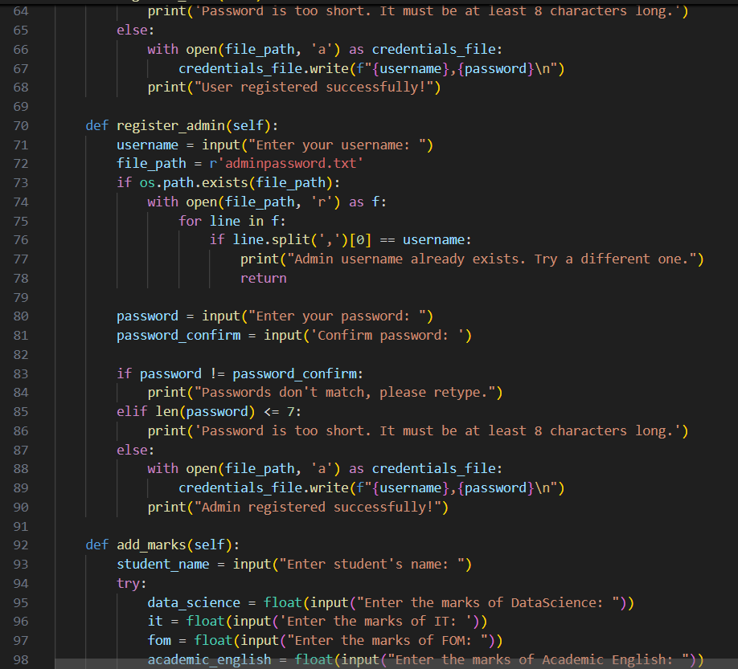

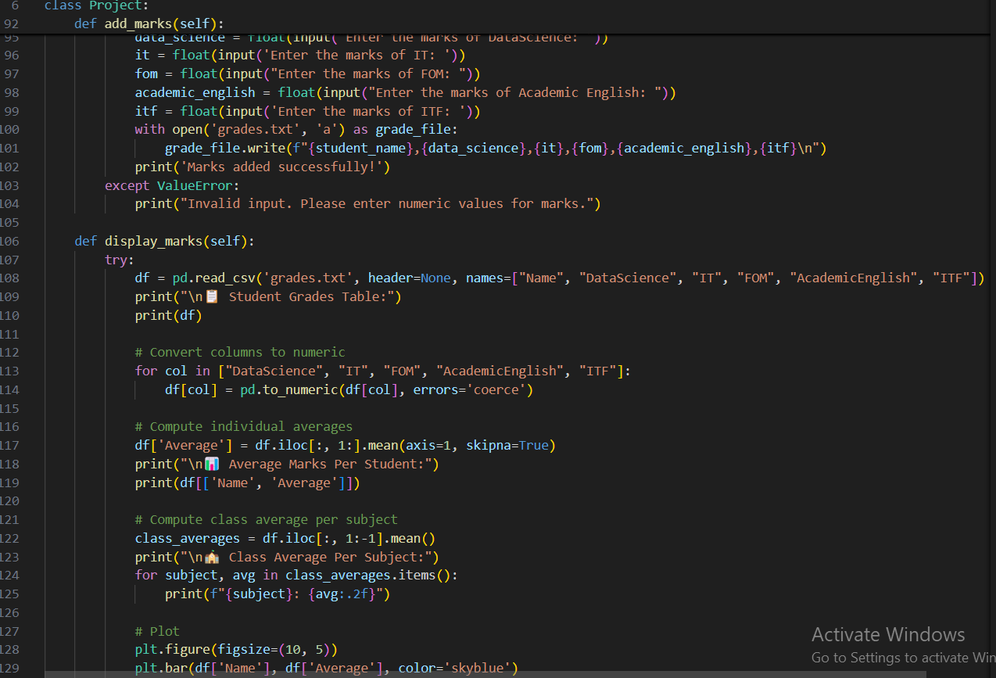

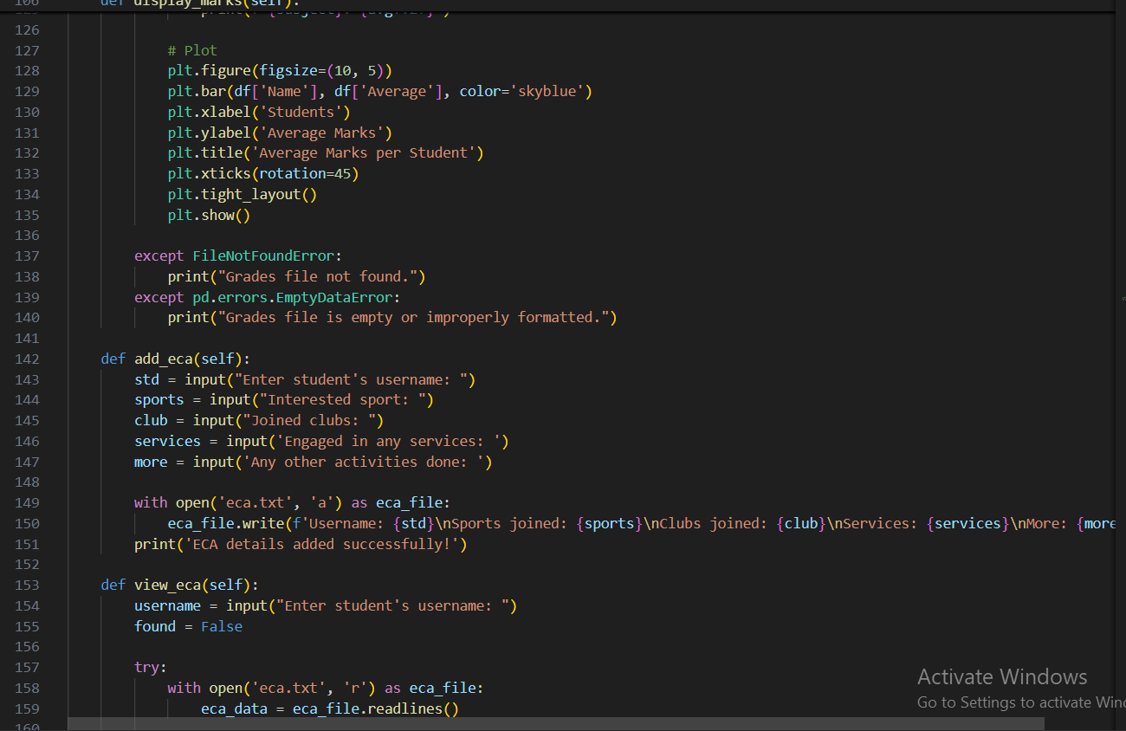

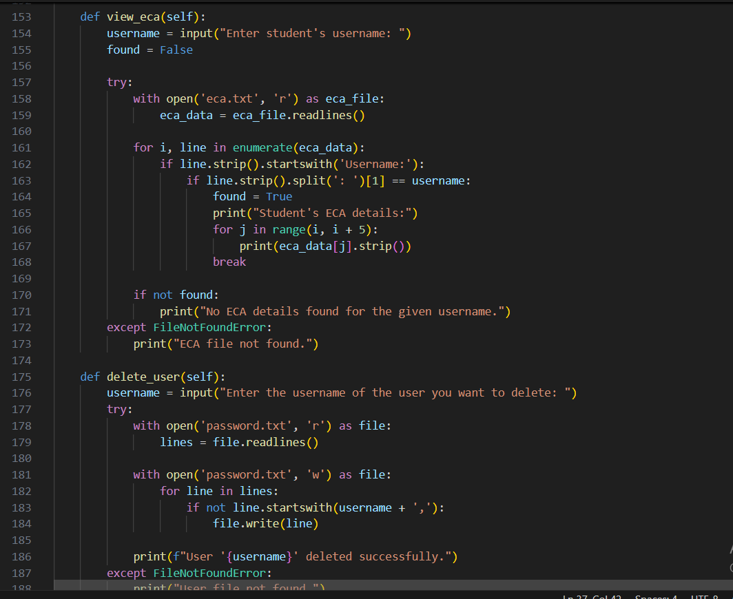

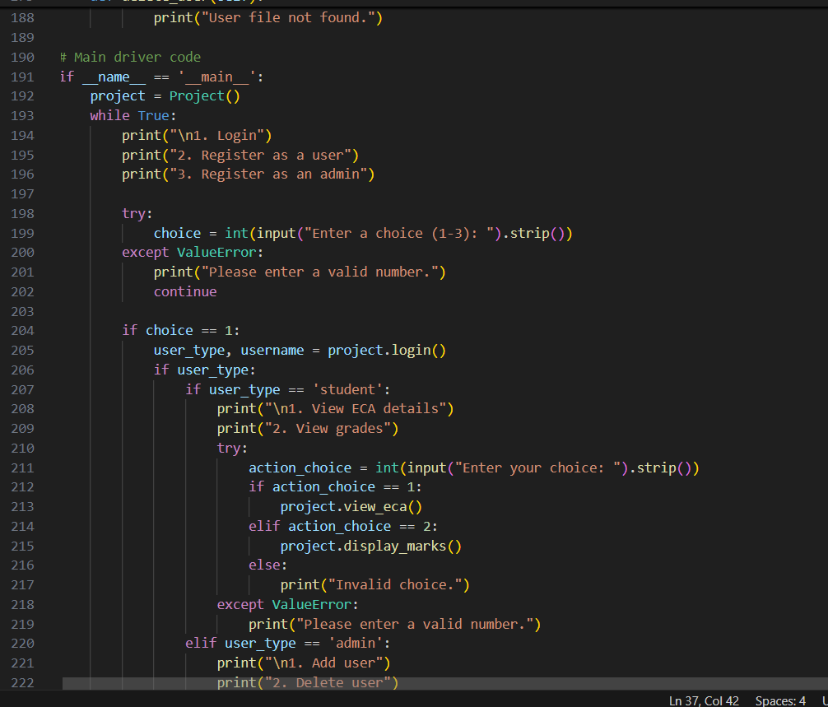

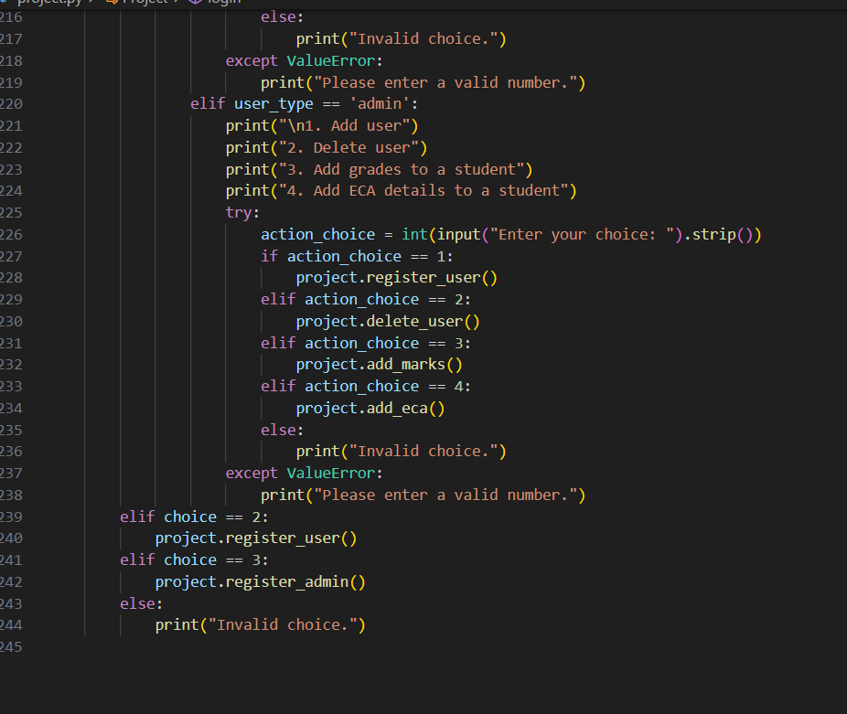

**Output**

**Output:**

**Firstly, registering as a user/student**

**Displaying the grade obtained by the user/student**

**Here, We haven’t added ECA details so that it shows “NO ECA details found”.**